London students become landscape architects during CAF funded workshop
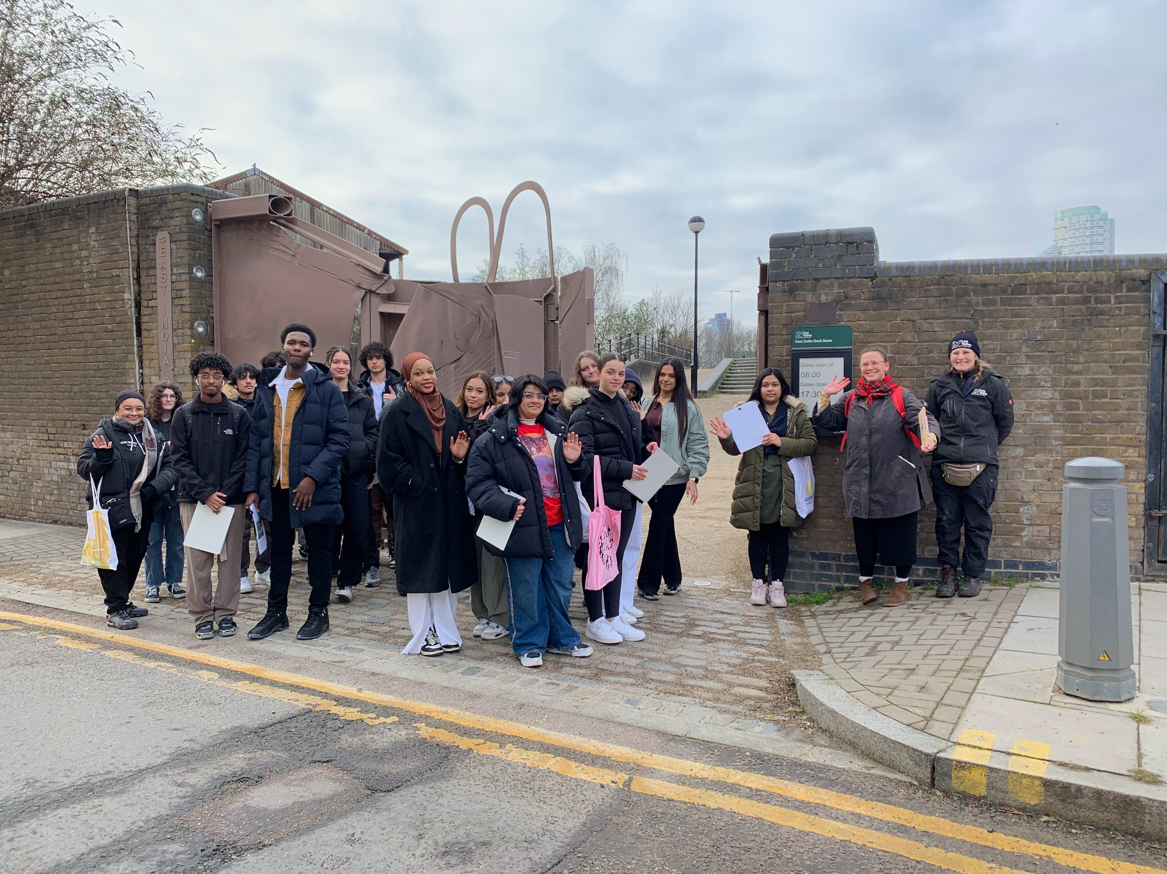

On Saturday 28 January a group of 31 students from Open City, a charity dedicated to making architecture and neighbourhoods more open, accessible and equitable, attended a workshop at East India Dock Basin funded by the Authority’s Community Access Fund.
The sixth form students, from 18 different London Boroughs, are members of Open City’s Accelerate Programme which supports young Londoners from under-represented groups who are interested in exploring potential careers in architecture, landscape and/or the built environment.
Lee Valley Ranger Kit gave students an overview of the East India Dock Basin. The site is significant for several reasons. It has particularly high significance for the local community, who value it as a quiet haven away from city life. It is an important ecological site and it’s the largest surviving portion of the once much larger East India Docks.
In 2020 the Authority formed a partnership with London Borough of Tower Hamlets to look at improvements to East India Dock Basin. A Shared Vision was developed outlining a range of opportunities to improve the site including desilting the Basin, restoring the dock gates, a visitor centre and improved interpretation, among other ideas. The Authority is in the process of completing a Heritage Lottery bid for this work.
Landscape architects, Spacehub shared some of their research and planning for the site before the students were tasked with developing their own creative response to one element of the proposed landscaping. The student’s ideas will then feed into Spacehub’s master plan for East India Dock Basin.
Students had a lengthy and lively discussion about the merits of the site and its potential, with suggestions including:
- Cafe and a range of outdoor seating
- More trees and greenery particularly by the entrance area
- Water fountains and lighting
- Art and sculptural installations to frame and animate the space
- Community art wall and community garden
- Community ‘pop up’ events: fetes, festivals, arts & craft markets
- Tern rafts could be pleasing to humans as well as birds
- Reuse industrial/heritage elements in new outdoor furniture

Students began to develop their initial thoughts and will submit their final artwork later this month. The artwork will form part of a public display at the Open City end of year exhibition in July.
The Authority will continue to work with Open City on further activity as part of the delivery of the East India Dock Basin project and the activation of the site.

