Open City Families Event East India Dock Basin Saturday 11th September 2021
Introduction
Through a partnership developed between the Lee Valley Regional Park Authority and the London Borough of Tower Hamlets the Park ran an event at East India Dock Basin for the Open City Families on Saturday September 11th 2021. This was part of the week long London Open House activities and was widely promoted.
The Park Authority ran two activities:
1) A guided walk lead by two experienced volunteers around The Lea Mouth Peninsula taking in EIDB, Bow Creek and Trinity Buoy Wharf.
2) A canal crafts family event run by the Youth and Schools department of the Lee Valley Park.
Also on the day the event was attended by the Lee Valley Regional Park Authority’s Head of Project and Funding Delivery who engaged with visitors. Discussion was undertaken on the Shared Vision developed by the partnership and about the project to interested people. Feedback and ideas were also taken on board to feed into the developing process and ideas for the site.
Event Analysis
Guided Walk
The guided walk was attended by 21 people who spent just under 2 hours being guided around East India Dock Basin, Bow Creek and Trinity Buoy Wharf. Feedback from the participants was excellent and there were no complaints from the group.
Attendees ranged from the following post code areas: N4, TW9, UB10, N8, HA4, SE9, CB10, E3, E14, N1, SW19, E15, SE16
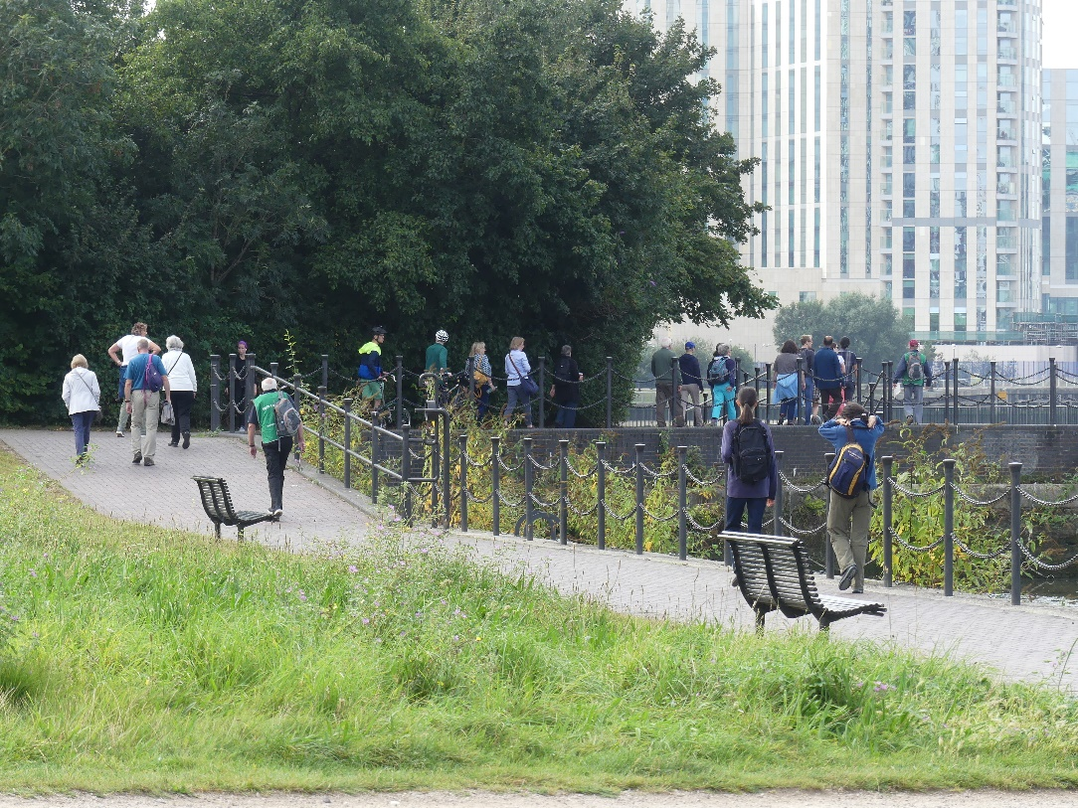
The guided walk setting off around East India Dock Basin
Family Event
The Family Event was attended by 14 children and 25 adults who came along at various times in the day to undertake the activities provided.
Attendees ranged from the following post code areas: E14, E16, E8, E5, EN3, SE13, SE1, W5, MK, CR8, HA4
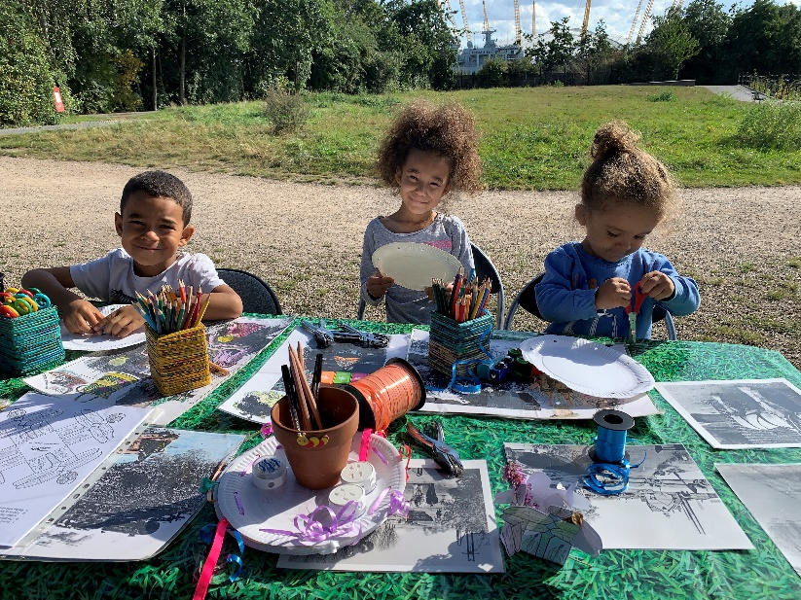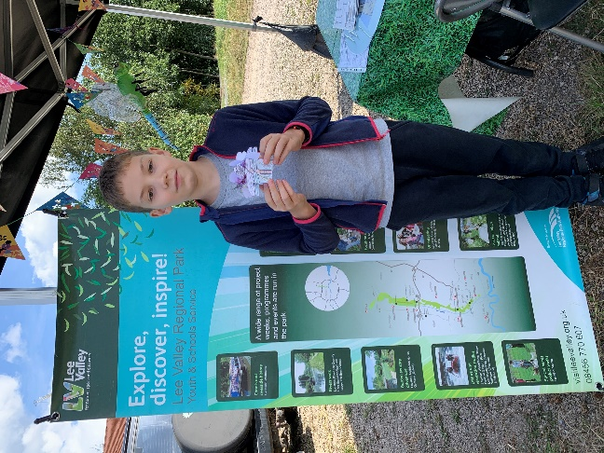
Feedback
A large number of discussions were undertaken with various locals and other visitors to the site during the day and a summary of key points, suggestions and ideas are listed below.
Feedback and ideas
- All visitors spoken to were concerned about the build up of silt. Some were unaware of the issues this caused to biodiversity where others were very knowledgeable and understood the detrimental situation that has developed through siltation of the basin. All agreed that it should be addressed and were concerned about the smell and health and safety implications of the current situation.
- Some visitors were unaware the site is managed as a nature reserve but were understanding when explained. Most see this as an amenity open space so perhaps we need to consider how we badge the site, the entrance signage and any interpretation that is part of the project.
- One visitor was of the opinion that the site was primarily used by dog walkers in the morning, joggers through the day and as a cut through to train stations at various times. This was observed during the day and appeared to be an accurate assessment. This visitor lived local and was keen to see the basin used by a wider and different audience. They were however very clear that they and many others do see this site as their own local open space in an area fairly deficient of open space provision.
- Entrances were raised by a few people and all were of the mind they were not particularly welcoming. The main entrance is actually oppressive and most people felt the gates and wall around the main entrance were oppressive and did not encourage people into the site. This was witnessed when the Head of Projects spent half an hour observing people walking past the site and very few were drawn in or interested in looking further past the entrance gate. One visitor suggested removing the gates, wall and creating a new entrance. Discussion was undertaken on if the gates could be an art feature in a different part of the site and this was welcomed by a couple of people.
- One visitor felt that the natural bowl by the entrance was an interesting place to develop and Amphitheater and performances could be given here for visitors to widen the interest of the site.
- Most visitors saw the Meadow as an area that was used by dogs for a toilet. Most said they avoided it because of the risk of stepping in something and they felt some work should be done to change the use of this piece of grassland. No ideas were forthcoming but it was clear we need to think about what we do with this area.
- The provision of a Café was discussed and raised a few times and it was unanimously agreed this would be a benefit along with public toilets.
- All entrances to the site were considered by different people to be not very welcoming and did not encourage you into the site. They were also unclear what sort of site it was and very few knew it was managed as a nature reserve.

